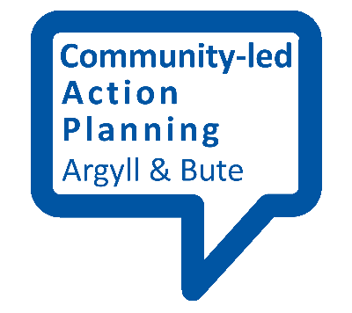
Community Visioning Event

This fact sheet provides an outline of a community visioning event.

To start with
Set a date and time that will suit as many people as possible and give plenty of notice. Ensure your venue is accessible, and big enough for your purposes. Get your publicity out and make sure that this information gets to everyone in an appropriate format. Make sure you contact all the local community groups to give them an opportunity to have a stall in the ‘marketplace’. They are also key to the success of the action planning process.

Programme
- Welcome/Opening remarks (by the group or possibly a local elected member)
Outline of the event and what it’s for – creating a vision for our community and making people aware of the community-led action planning process

- Opportunity for people to circulate round the venue, view the research and profile information and speak to the groups in the marketplace
- Display of the research findings – including analysis of any surveys, profile information, asset mapping exercise
- Stalls/marketplace – for all local groups to present information about what they do

- Short presentation on the findings from the research/asset mapping stage by the group

- Group discussion exercise - Creating a ‘Vision’ for the Community (see fact sheet – “what makes a good vision”)
  - Consideration of what the community might look like in 5 years time or longer
  - Identifying key words/phrases – you can use word cloud methods or apps such as Menti (www.menti.com) to help do this in a more interactive way.
  - Develop a broad vision statement

- Community priorities – taking into account the findings from the research, the assets or strengths that exist, and people’s vision for the future what are the broad themes that need to be addressed through the action plan? Participants should identify these broad themes (e.g. public transport links, environmental issues, community facilities, etc.) through discussion and write them up on large post-its or flipcharts. Once these broad themes are displayed you may want to get a sense of priorities by giving people a number of votes (sticky dots or similar) which they can set against the themes according to how important or urgent they consider the need for action is.

Drawing conclusions
By the end of this session you should have an overall draft ‘vision’ for your community – this can be refined further at the next stage. You should also have a sense of what the priority themes for action are which will form the basis for the creation of your action plan.

