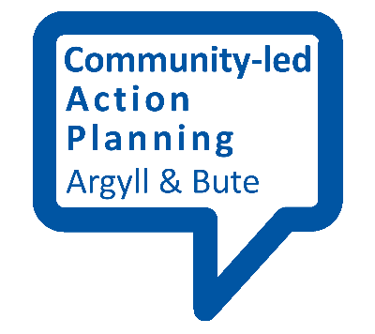
Using existing evidence

Some of the information you will need for your community-led action planning will exist already. This includes information on local services, facilities, assets and relevant agencies, organisations and groups. Up to date statistical data on the profile of your community may also already exist.

Online information
In some cases, this information will be available online. An example of online information is Argyll and Bute Council’s register of land and assets, which has been set up in light of new duties for public agencies in the Community Empowerment (Scotland) Act.
Other useful online information may include:
- Policies and plans of organisations and agencies working locally, such as Argyll and Bute’s Community Planning Partnership.

- Statistical information on your community, such as the Health and Wellbeing Profile of your local area, Scotland’s Census and the Social Index of Multiple Deprivation.

- Data on local history and the environment such as the National Records of Scotland’s online search facility.

Online searching
If you don’t know exactly where you will find the information you want, you will need to think about how best to search for it online. The following tips can be useful when conducting online searches:
- Be as specific as possible to narrow down your results.

- Try using longer phrases in quotation marks rather than separate words. This may not work the first time but you can refine your search for better results.

- Consider adding words and/or phrases to provide extra information on what you are interested in. For example, if you were searching for existing profiles on your community you might want to add the current, or previous, year to ensure you get the most up-to-date information.

- Use Boolean operators such as ‘and’, ‘or’ and ‘not’.

Off-line existing evidence
There will also be existing information on your community that is not online. Examples include:
- Local libraries.

- Archived information. For instance, much of the information held by the National Records of Scotland has to be requested. Argyll and Bute Council also has an offline archive.

- Information stored by organisations and agencies working locally, both in the public and private sector.

- Local groups, such as local history societies, environmental groups, sport clubs and organisations formed around a shared identity (e.g. disability) or interest (e.g. campaign groups).

- Local newspaper archives.

