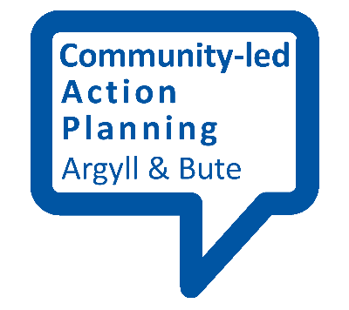
Running a focus group
Used alongside other methods, focus groups can be a useful way to explore issues in more detail or to find out the views of particular groups of people.

Why run a focus group?
Focus groups are good for getting in depth views from a relatively small number of people, who may have a shared interest or background. They are particularly good for exploring questions in more depth, and people’s ideas can build on and challenge one another’s. You might use a focus group to discuss some findings that you already have or to explore ideas. The format also provides an opportunity to ask why people have come to a particular view and generally probe answers.

What is involved?
A focus group usually runs for about two hours with around 7-15 people in total who will be asked their views on a set of questions relevant to your community-led action plan. For this to work effectively, it is a good idea to have both a facilitator to guide the discussion and a second person to take notes.
Focus groups often take place in a quiet room or space where people are unlikely to be disturbed. At the same time, you can be creative about the location. For instance, an outdoor focus group in a location that means something to the community may help to prompt people and stimulate discussion.
Likewise, the format of a focus group can vary. A group discussion may work well, but sometimes smaller group discussions might be a good way to encourage less confident people to join in. The use of aids like flip chart paper, photographs and post-its may further stimulate discussion. It is good if you can use a range of methods to give variety and maintain interest.

Planning
To work well, focus groups should be well-planned in advance. Think of the questions you want to ask and set them out as a topic guide. This will ensure you get the information you are looking for. However, it also shouldn’t be thought of as a rigid structure – the discussion should be able to develop without too much steering, which may lead to issues that you hadn’t thought of being explored. If the conversation goes off topic then the guide can be used to get it back ‘on topic’.
Other things to think about beforehand include:
- When to hold the focus group – it will be good to think of a time that suits people
- Giving people prompt and accurate information about when and where the focus group will take place
- Any support needs people may have, including access, travel costs, childcare and support for anyone with hearing difficulties
- Refreshments – to stop people from ‘flagging’ and also to help ‘break the ice’
- The availability of toilets

Consent and confidentiality
If you are going to record or film the focus group you need a consent form for people to agree to and sign at the beginning of the focus group session. Consent will also be required if you want to take photographs. A common approach is to provide a statement making it clear that people agree to letting you use what they say but can withdraw their consent at any point. It is also important to make it clear that quotes and views will be used anonymously and that all information will be stored securely.

On the day
Once everyone has arrived, introduce the focus group and what you are hoping to achieve. Talk people through how things will work, including the issues of consent and anonymity. Some people may require more support to understand this and to complete the form.
Get people to introduce themselves before starting. It may also be good to set a few ‘ground rules’ out, such as asking people not to interrupt each other and to respect each other’s opinion.
Start the discussion with some easier or lighter questions so that people can begin to feel more comfortable before talking about anything more controversial or divisive. Remember to use your topic guide to help cover all the areas you want to or if you need to get the conversation back on track. At the same time, wherever possible it is best to allow the discussion to flow naturally.
Take some time at the end of the focus group to sum up what the key messages have been. This will give participants a chance to clarify anything that you may have misunderstood, saving trouble in the longer term. Thank the group, inform them what will happen next and how you will feedback the findings of the research to them.

Next steps
See the rest of the Finding Out section for what to do with your research findings once you have gathered them.

