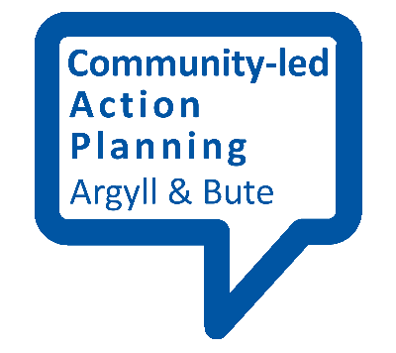
Stakeholder Analysis

This fact sheet provides an outline of a session for identifying how potential partners can help with your community-led action plan.

To start with
Having identified a number of key local groups and agencies (your stakeholders) to be involved it is useful to establish why it is important for them to be involved, what they can bring to the plan (and its implementation), and what opportunities might exist to take the plan forward. To do this it is useful to bring them together for a discussion session.
Split participants into their ‘groups’ – the core or lead group (that’s you), other community group representatives, agency representatives and ask them to consider the following questions:

Motivation, Capacity and Opportunity

Motivation:
- What motivates and encourages you, your group and/or your agency to be involved in community-led action planning?
- Why are you involved, why do you want to be involved?
- What benefits do you see from your involvement (for the community and for your group/agency)

Capacity:
- Do we have the ability, skills and confidence to do what’s needed?
- Do we have the resources (money, physical assets, time and energy) to do what’s needed?
- Is there anyone else we need to be speaking to (who can bring skills and resources)?

Opportunity:
- Are there any existing opportunities for us to achieve our purpose?
- Are there any quick wins?
- Are there opportunities to involve more people from the community or other agencies?

Drawing conclusions
Participants should be asked to write up their responses and place them on the appropriate section of a large grid (see the sample stakeholder tables provided in the reaching out section).
Once this is done then all participants should have the chance to discuss the responses and agree a final ‘stakeholder’ analysis which will form the basis for partner contributions to the plan.
Any gaps (in community involvement and/or agency support) should also be identified at this stage. You may find you need to revisit some of the earlier steps in the community-led action plan cycle to ensure you have given everyone a chance to take part. Both the finding out and reaching out stages are relevant here.

