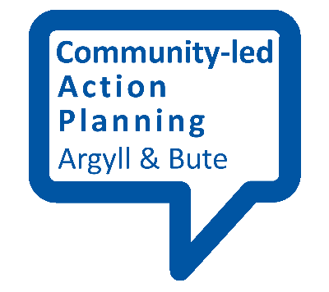
What does a good Community-led Action Plan contain?

This fact sheet provides an outline of what a good Community Action Plan might contain.

To start with:
A good action plan should tell the community, partners and funders all about your place – what is unique about it, what you are good at and what issues there are. It should contain actions that will help with the issues and build on what the good things (assets) are.

Headings – select those that seem important and put them in any order.
An introduction should set the scene, and “sell” your community as one worth investing in.
Validity – you need to provide justification for your findings. A brief discussion of how you conducted your research, what percent of the population participated and how you included those members of the community that find it harder to get involved – for example young people, minority groups or disabled people.
Community profile - tell people a bit about your place. How many live there? What are the key facilities? What do people like about your place? What do they hate and what do they want to change? A few statistics and a few quotes from residents can bring the unique character of your place to life.
Action plan - this is sometimes in the form of a table or grid. The actions are usually described quite simply, (see SMART objectives fact sheet) and have partners assigned to them. It is useful to discuss actions that depend on external partners beforehand with them, to make sure they are the right people and have the resources available to help you.
Review – it can be worth noting a review date and who is responsible for conducting it.
Contact details – any partner or volunteer who reads your plan should be able to get in touch to offer help. Ensure they know how, for example through a generic email address that will be relevant for the length of your plan.
Pictures, maps, photos, drawings can all add colour, attractiveness and additional detail. Perhaps you could photograph one of your community consultation events. Remember to credit the photographer.
Accessibility – You should consider making your plan as accessible to a wide audience as possible and, depending on your communities makeup, you could include other languages, easy read, or audible clips for people who can’t read. There is help on making a document accessible here.
Credit to funders and volunteers – don’t forget to say thank you to people who deserve it.
Accountability- how will you report progress to your community? You could set up a steering group of key partners to review progress or identify bottlenecks at regular intervals.

Broadcasting your action plan:
You should make sure your new action plan is available and accessible. You can put it on your community website. It could be emailed to partners/residents and funders. Let the world know your place has ambitions, has a plan and is ready to deliver improvements!

